**Accessing SHAPE America Journals through the**

**Taylor & Francis website**

1. Go to <https://portal.shapeamerica.org/MemberPortal/SHAPE_Sign_I.aspx>
2. Enter your **username (your email address)** and **password (you created)** into the correct fields
3. Click on **your name** on top right of screen (see below)
4. Click **My Journal** from drop down menu (see below)



1. Click JOPERD link, or the journal(s) you subscribe to (see below):

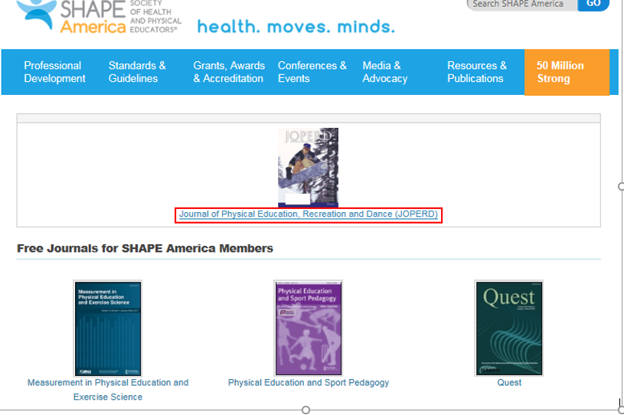

1. Subscriber should now see the page below:

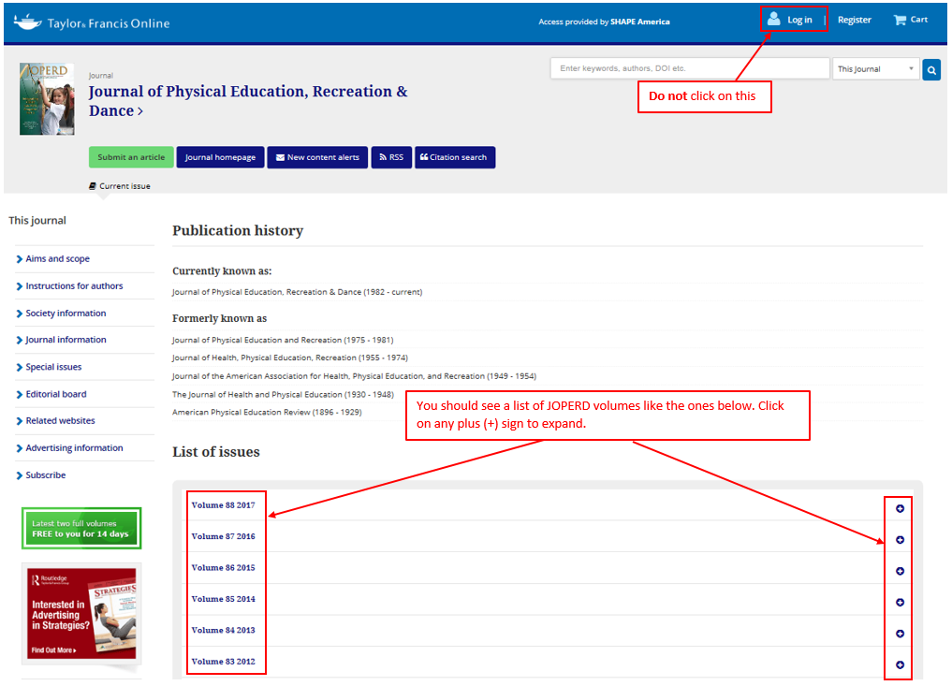

***PLEASE NOTE:* The four steps above must be completed/followed.** Taylor & Francisuses a “referring URL” to allow access.  The “referral URL” needs to be <http://portal.shapeamerica.org/trn-MyJournals>.  Subscribers cannot use bookmarks or use another other linkage to Taylor and Francis, the above steps must be completed for access.

***IN ADDITION,*** when subscribers are at the Taylor & Francis site,there is a login button in the upper right-hand corner.  That is the login for Taylor & Francis, however, they **do not** need to login again there.  If they followed the four steps above, they already have access to their journal subscriptions.